CARA INSTALL VISUAL BASIC 6

1. Download file **Visual Basic 6.0 Enterprise Edition.Exe** (gunakan Web.Whatsapp.Com di laptop atau PC, jangan gunakan HP)
2. Double klik file **Visual Basic 6.0 Enterprise Edition.Exe** hasil download
3. Klik tombol **Unzip**
4. Klik drive **C:**
5. Klik folder **Vbasic6**
6. Double klik folder **Visual Basic 6.0 Enterprise Edition**
7. Double klik file **SETUP.EXE**
8. Klik tombol **Next**
9. Klik OptionButtom (lingkaran) **I accept the agreement**

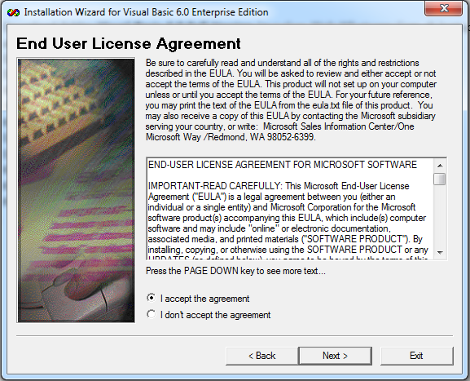

1. Klik tombol **Next**
2. Ketik nomor produk **812-2224558**

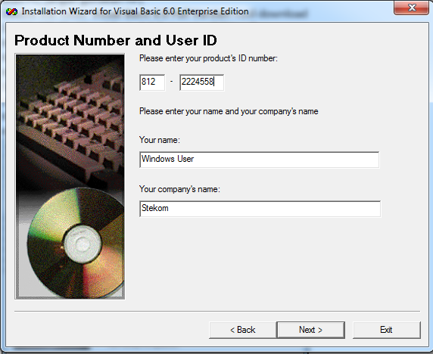

1. Klik tombol **Next, Next, Continue, OK**
2. Klik tombol **Typical**

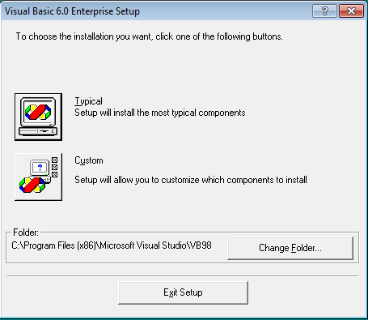

1. Klik tombol **Restart Windows**
2. Jika tampil windows **Install MSDN**, hilangkan tanda centang di CheckBox (klik kotak) pada **Install MSDN**
3. Klik tombol **Next, Yes**
4. Jika tampil windows **Register Over the Web Now**, hilangkan tanda centang di CheckBox (klik kotak) pada **Register Now**
5. Klik tombol **Finish**
6. Masuk ke **Windows Explorer**
7. Masuk ke folder **C:\Program Files (x86)\Microsoft Visual Studio\VB98**
8. Double klik file **VB6.EXE**